LABIP Expert Workshop

“Bio-preservation through fermentation, a natural and sustainable process? Opportunities, Risks and Regulation”

27 – 28 September 2021

Brugge

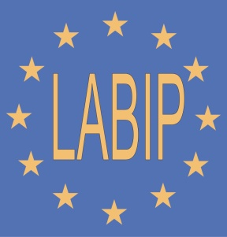

The aim of our LABIP Expert Workshop September 27-28 2021, is to discuss the opportunities, risks and regulation that are involved in using fermentation as a way to a natural bio-preservation of foods. The different aspects involved will be presented by invited experts, each of who will shed her/his light on this old traditional technique which have gained a lot of attention in the public space during the recent years. The presented point of views will be open for discussion during the workshop.
We intent to prepare a consensus document with the outcome of the expert workshop and which is due to be publish in a scientific journal.
The full program of the meeting can be found below. We welcome you in the beautiful city of Bruges and wish you a very inspiring meeting. We feel extremely happy as for many of you this might also be one of the first face-to-face meetings again after a long period of computer screen meetings.
We like to thank the speakers for their willingness to travel to Bruges, and LABIP for logistical and financial support.
The organizing committee.
Programme
Monday September 27

12.00-13.30 Arrival, registration and lunch
13.30-14.00 Welcome and introduction
Esben Laulund, Charmain LABIP

14.00-14.30 Holistic introduction –The effect of the LAB fermentation process for the global food production chain and Human well-being
Christophe Chassard, INRA

14.30-15.00 Bio-preservation feeds the world
Christoph Lacroix. ETH Zurich

15.00-15.30 Regulatory issues in relation to the application of LABs in food production
Bernd van der Meulen, University of Copenhagen and Renmin University of China (Beijing)

15.30-16.00 Coffee/Tea break

16.00-16.30 What can be learned from traditional fermentation?
Jeroen Hugenholtz, Wageningen Food & Biobased Research

16.30-17.00 How can fermentation outcompete chemical preservation methods in modern food production?
Michael Callanan, Cork Institute of Technology

17.00-17.30 New trends in fermentation: safety and risks of homemade fermentation
John Leech, TEAGASC, Ireland

17.30-18.00 Potential of bacteriophages or other phage-based means of Biopreservation Beatriz Martinez, Ipla-Csic, Spain

18.00-19.00 LABIP General Assembly – LABIP representatives only

19.00-22-00 Drinks and Diner

Tuesday September 28

9.00-9.30 A perspective on trends in natural fermentation at restaurants, artisanal producers and for private consumption
Michael Bom Frost, University of Copenhagen

9.30-10.00 Economic benefits – reducing food waste
Peter Thoeysen, Chr. Hansen

10.00-10.30 Fermentation of plant proteins: Influence on flavor, texture and bio-preservation
Herwig Bachmann, NIZO

10.30-11.00 Coffee/Tea break

11.00-12.30 Wrap up session

12.30-13.30 Lunch and departure

Organising Committee
Aat Ledeboer LABIP Secretary
Arjen Nauta LABIP Treasure / FrieslandCampina
Bruno Pot Yakult
Esben Laulund LABIP Chairman / Chr. Hansen
Patrick Boyaval IFF
Sophie Legrain Lesaffre
Stéphane Duboux Nestlé

The Venue
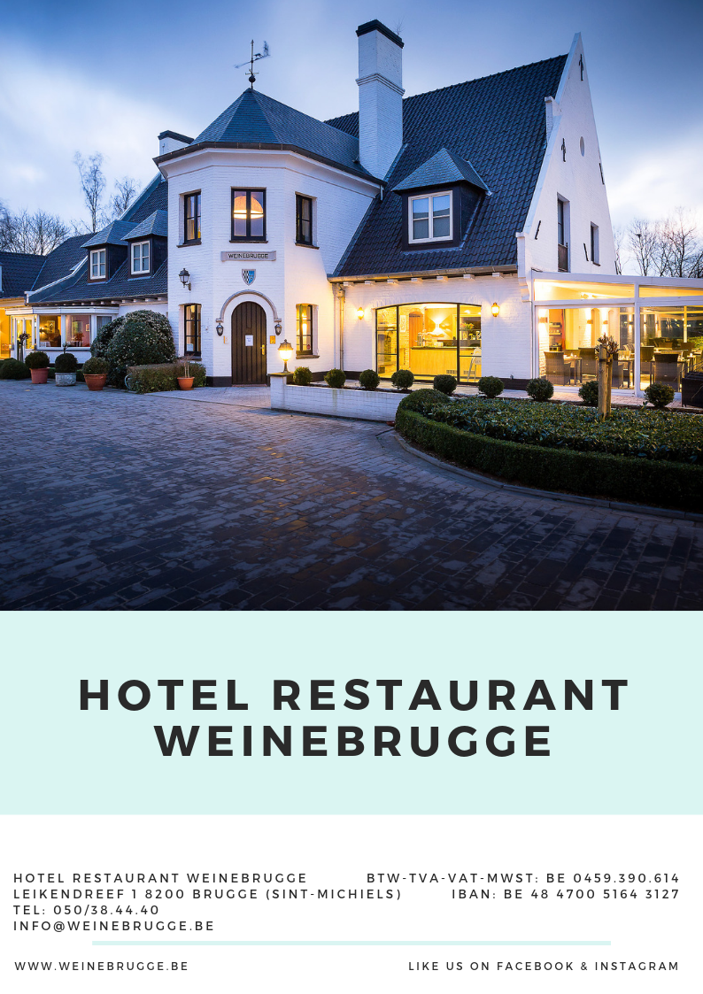

Name | Company | E-mail
Alain Sourabié | Procelys by Lesaffre | a.sourabie@procelys.lesaffre.com
Arjen Nauta | FrieslandCampina | arjen.nauta@frieslandcampina.com
Bruno Pot | Yakult | BPot@yakulteurope.com
Daniella Lucena | Arla | DANLU@arlafoods.com
Esben Laulund | Chr. Hansen | DKEL@chr-hansen.com
Ingeborg Haagsma | Westland Kaas b.v. | Ingeborg.Haagsma@Westland-Kaas.nl
Jean-Michel Faurie | Danone | Jean-Michel.FAURIE@danone.com
Mariella Kuilman | DSM | Mariella.Kuilman@DSM.COM
Markus Brandt | Ernst Böcker | markus.brandt@sauerteig.de
Morten Thybo | Arla | MOTHY@arlafoods.com
Patrice Antoine | THT | patrice.antoine@tht.be
Patrice Laforce | Lallemand | plaforce@lallemand.com
Patrick Boyaval | IFF | Patrick.Boyaval@dupont.com
Sofia Dashko | DSM | Sofia.Dashko@dsm.com
Sophie Legrain | Gnosis by Lesaffre | s.legrain@lhc.lesaffre.com
Svend Laulund | Chr. Hansen | dksl@chr-hansen.com
Tadhg O'Sullivan | Heineken | Tadhg.OSullivan@heineken.com
Aat Ledeboer | LABIP | aat.ledeboer@hetnet.nl
Participants
Speakers/Experts | Affiliation | E-mail
Beatriz Martinez | Ipla Csic, Spain | bmf1@ipla.csic.es
Bernd van der Meulen | University of Copenhagen and Renmin University of China | Bernd.vanderMeulen@food-law.nl
Christoph Lacroix | ETH Zurich | christophe.lacroix@hest.ethz.ch
Christophe Chassard | INRA | christophe.chassard@inrae.fr
Herwig Bachmann | NIZO | Herwig.Bachmann@nizo.com
Jeroen Hugenholtz | Wageningen Food & Biobased Research | jeroen.hugenholtz@wur.nl
John Leech | Teagasc, Ireland | John.leech@teagasc.ie
Michael Bom Frost | University of Copenhagen | mbf@food.ku.dk
Michael Callanan | Cork Institue of Technology | Michael.Callanan@cit.ie
Peter Thoeysen | Ch. Hansen | dkpetr@chr-hansen.com
Name | Company | E-mail
Biljana Bogicevic | Nestlé | Biljana.Bogicevic@rdko.nestle.com
Stéphane Duboux | Nestlé | Stephane.Duboux@rdls.nestle.com
Simon Pedersen | Arla | simpe@arlafoods.com
Jan Willem Sanders | Unilever Research | Jan-Willem.Sanders@unilever.com

